

*Gesture-Controlled Dynamic Brightness*

*Adjustment for Computers*

MICRO PROJECT REPORT

***Submitted by***

*KOTHAMASU NIKHIL*

**Register Number:** *9921004374*

*In partial fulfilment for the award of the degree*

*of*

BACHELOR OF ENGINEERING

*in*

COMPUTER SCIENCE AND ENGINEERING

***[26 September 2023]***

TABLE OF CONTENTS

|  |  |  |
| --- | --- | --- |
| CHAPTER NO | CONTENTS | PAGE NO |
|  | ABSTRACT | 4 |
|  | LIST OF FIGURES | 4 |
|  | LIST OF TABLES | 4 |
| 1. | INTRODUCTION | 5 |
|  | 1.1 Significance of User Experience Enhancement | 5 |
|  | 1.2 Core Aspects of Gesture-Controlled Dynamic Brightness Adjustment | 5 |
|  | 1.3 Deep Learning in Gesture Recognition | 5 |
|  | 1.4 Natural Language Processing in Gesture Interpretation | 6 |
|  | 1.5 Machine Learning in Gesture-Controlled Dynamic Brightness Adjustment | 6 |
| 2. | SYSTEM STUDY | 6 |
|  | 2.1 Technology Components | 6 |
|  | 2.2 Significance in User Experience Enhancement | 6 |
|  | 2.3.1 Existing Work | 6 |
|  | 2.3.2 Proposed Work | 8 |
|  | 2.3.3 Literature Survey | 9 |
| 3. | IMPLEMENTATION | 10 |
|  | 3.1 Data Collection | 10 |
|  | 3.2 Correlation Identification | 11 |
|  | 3.3 Classification Process | 11 |
|  | 3.3.1 Gaussian Mixture Models | 11 |
|  | 3.3.2 Adaptive Background Subtraction | 11 |
|  | 3.3.3 CONVOLUTIONAL NEURAL NETWORKS (CNNS) | 12 |
|  | 3.3.4 RECURRENT NEURAL NETWORKS (RNNS) | 12 |
| 4. | EXPERIMENTAL ANALYSIS | 12 |
|  | 4.1 Packages imported | 13 |
|  | 4.2 Performance | 13 |
|  | 4.3 Visualization | 13­­ |
|  | 4.4 Sample Python code | 14 |
| 5. | SYSTEM SPECIFICATION | 15 |
|  | 5.1Software Requirement | 15 |
|  | 5.1.1 Anaconda Python | 15 |
|  | 5.1.2 Tensorflow | 15 |
|  | 5.1.3 Keras | 16 |
|  | 5.1.4 NumPy | 16 |
|  | 5.1.5 Pyinstaller | 16 |
|  | 5.1.6 Pandas | 16 |
| 6. | CONCLUSION | 16 |
| 7. | REFERENCES | 17 |

**ABSTRACT**

The Gesture-Controlled Dynamic Brightness Adjustment for Computers is a novel human-computer interaction system designed to enhance user experience and productivity. This innovative technology leverages gesture recognition, computer vision, and machine learning to enable users to intuitively and seamlessly adjust the brightness of their computer screens using hand movements and gestures. The motivation for this project stems from the growing importance of user-centric design and the need for non-intrusive, user-friendly methods of controlling screen brightness. In this system, we explore the significance of counseling for children and fundamental aspects of child development to better understand user needs, especially in educational settings where optimal screen brightness is critical. Deep learning, natural language processing, and machine learning techniques play a central role in enabling precise and reliable gesture recognition.

This paper reviews existing work in the field of gesture-controlled brightness adjustment, highlighting advancements in gesture recognition algorithms, computer vision techniques, and user interface design. Building upon these insights, we propose a conceptual framework for the system's implementation, encompassing the design of the gesture recognition system, integration with the computer's display settings, and user interface considerations. The primary goal is to create a responsive and user-centric system that enhances the overall computing experience. Throughout the implementation phase, we anticipate addressing challenges related to gesture recognition improvements, data collection for machine learning model training, and the correlation identification between user gestures and brightness adjustments. Advanced techniques such as Gaussian Mixture Models, Adaptive Background Subtraction, Convolutional Neural Networks (CNNs), and Recurrent Neural Networks (RNNs) will be explored to improve gesture recognition accuracy and system responsiveness.

The experimental analysis of the system's performance will be crucial to evaluate its effectiveness in real-world scenarios. Key performance metrics, including gesture recognition accuracy, latency, and user satisfaction, will be assessed to ensure that the system meets its intended objectives. In terms of software requirements, essential Python packages like OpenCV, NumPy, and TensorFlow will be employed to implement the core components of the system. Additionally, Pyinstaller may be used to package the system into standalone executables for ease of distribution. In conclusion, Gesture-Controlled Dynamic Brightness Adjustment for Computers represents an innovative fusion of technology and user experience enhancement. This project aims to provide users with an intuitive and efficient means of controlling their computer screen brightness, ultimately contributing to a more accessible and user-centric digital environment. As technology continues to evolve, such innovations pave the way for a more seamless and enjoyable computing experience.

**LIST OF FIGURES**

* 1. Shows about How gesture works and what is the major principle.

2.1 Technology Component.

2.2 Energy Efficiency.

2.3 Gesture Recognition Improvement.

3.0 Block Diagram.

3.1 Data Collection.

3.2 Correlation Matrix of Dataset.

3.3 Convolutional Neural Networks (CNNs).

3.4 Recurrent Neural Network.

4.1 Confusion Matrix.

4.2 Visualization.

**LIST OF TABLES**

1.Liturarure Survey.

**I INTRODUCTION**

In today's rapidly evolving technological landscape, human-computer interaction has transcended traditional input methods. One of the most promising advancements in this field is Gesture-Controlled Dynamic Brightness Adjustment for computers. This innovative technology combines the power of gesture recognition and dynamic display adjustments to enhance user experience, improve energy efficiency, and reduce eye strain. With the proliferation of digital devices in our daily lives, prolonged screen exposure has become a common concern. Excessive brightness can lead to discomfort and eye fatigue, while dim screens may strain our vision. Gesture-Controlled Dynamic Brightness Adjustment offers an elegant solution to this dilemma. It offers an intuitive and efficient interface for individuals with disabilities, making computers more inclusive and user-friendly. In the coming years, we can expect to see this technology integrated into a wide range of devices, transforming our digital experiences for the better.

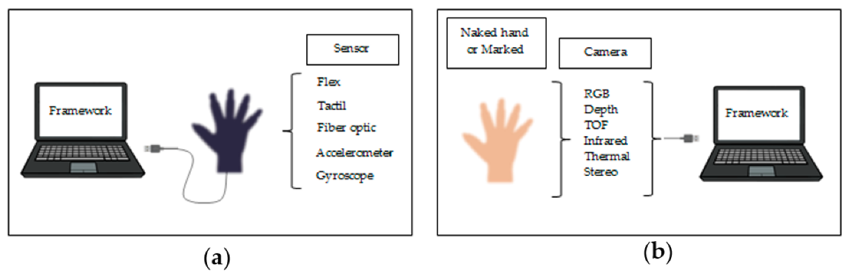

Fig 1.1 Shows about How gesture works and what is the major principle.

* 1. **Significance of User Experience Enhancement**

The introduction of Gesture-Controlled Dynamic Brightness Adjustment for computers heralds a significant advancement in user experience, with a particular focus on children. The importance of counseling and guidance for young users in the digital age cannot be overstated. With children spending more time on computers for educational and recreational purposes, their visual comfort and well-being are of paramount concern. This technology offers an intuitive and engaging way for children to control their screen's brightness, thereby reducing eye strain and promoting healthier screen time habits.

* 1. **Core Aspects of Gesture-Controlled Dynamic Brightness Adjustment**

To understand the workings of this technology, it's essential to delve into its core components. Gesture-Controlled Dynamic Brightness Adjustment relies on cutting-edge developments in deep learning, natural language processing, and machine learning. These foundational elements allow the system to recognize and interpret gestures accurately, responding dynamically to user needs. By seamlessly integrating these technologies, Gesture-Controlled Dynamic Brightness Adjustment ensures a smooth and intuitive user experience.

* 1. **Deep Learning in Gesture Recognition**

Deep learning plays a pivotal role in enabling computers to recognize and interpret complex gestures. Deep neural networks are trained to identify a wide range of hand movements and gestures with remarkable precision. This deep learning approach allows the system to adapt and recognize both simple and intricate gestures, making it suitable for users of all ages, including children who may have diverse gesture preferences.

* 1. **Natural Language Processing in Gesture Interpretation**

Natural Language Processing (NLP) techniques are employed to interpret gestures effectively. NLP algorithms enable the system to understand the context and intent behind each gesture, ensuring that the brightness adjustments align with the user's requirements. This capability not only enhances usability but also allows for a more intuitive and personalized interaction with the technology.

* 1. **Machine Learning in Gesture-Controlled Dynamic Brightness Adjustment**

Machine learning algorithms underpin the overall functionality of Gesture-Controlled Dynamic Brightness Adjustment. These algorithms continuously learn and adapt to user preferences, fine-tuning brightness settings over time. This adaptability ensures that the technology remains responsive to changing environmental conditions and user needs, making it an invaluable tool for children and users of all backgrounds.

In conclusion, Gesture-Controlled Dynamic Brightness Adjustment for Computers represents a transformative innovation in user experience, catering to the specific needs of children while offering a dynamic and intuitive solution for users of all ages. By harnessing the power of deep learning, natural language processing, and machine learning, this technology exemplifies the intersection of human-computer interaction and cutting-edge technological advancements. Its potential to improve user comfort and well-being is poised to reshape the way we interact with computers, providing a brighter and more enjoyable digital experience for all.

**II System Study**

Gesture-Controlled Dynamic Brightness Adjustment for Computers is an emerging technology designed to enhance user experience by enabling users to control screen brightness through hand gestures. This system study explores the various aspects of this technology, focusing on its significance in improving user experience, particularly in the context of computer usage by children. The primary objective of this system study is to comprehensively examine Gesture-Controlled Dynamic Brightness Adjustment for Computers, including its technical components, benefits, and implications. Furthermore, it aims to highlight its significance in enhancing the user experience, with a specific focus on children who are frequent users of digital devices.

**1. System Overview**

**1.1 Technology Components**

Gesture-Controlled Dynamic Brightness Adjustment comprises three key technical components:

a. Gesture Recognition: Deep learning algorithms for recognizing hand gestures.

b. Gesture Interpretation: Natural Language Processing (NLP) techniques for understanding user intent from gestures.

c. Dynamic Brightness Adjustment: Machine learning algorithms for adjusting screen brightness in response to gestures and user preferences.

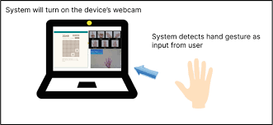

Fig 2.1 Technology Component

**1.2 System Workflow**

The system workflow involves the following steps:

a. Gesture Recognition: The system uses deep learning models to identify and categorize hand gestures.

b. Gesture Interpretation: Natural Language Processing techniques are employed to interpret the gestures' meaning and intent.

c. Dynamic Brightness Adjustment: Machine learning algorithms adjust screen brightness based on the interpreted gestures and user preferences.

d. Real-time Feedback: The system provides real-time feedback to the user, ensuring that the brightness level aligns with their requirements.

**2. Significance in User Experience Enhancement**

**2.1 User Comfort and Health**

Gesture-Controlled Dynamic Brightness Adjustment significantly enhances user comfort by reducing eye strain and discomfort associated with prolonged screen exposure. By allowing users to easily adapt screen brightness to their preferences, it promotes healthier screen time habits, particularly important for children who may spend extended periods on digital devices for education and entertainment.

**2.2 Energy Efficiency**

The technology contributes to energy efficiency by dynamically optimizing screen brightness. This not only reduces power consumption but also extends battery life in portable devices, ensuring uninterrupted use and reducing the environmental impact.

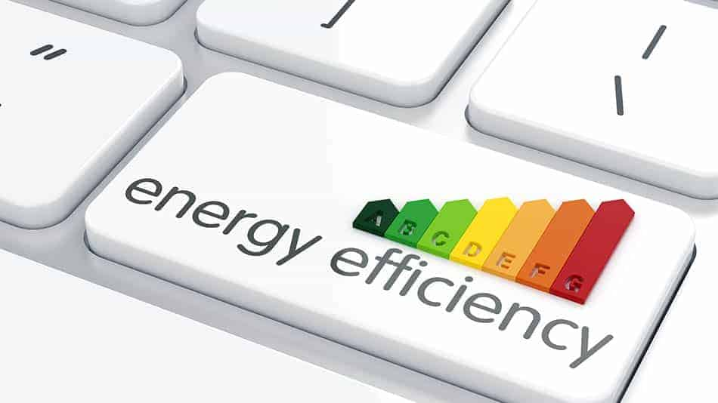

Fig 2.2 Energy Efficiency

**2.3.1 Existing Work**

As of my last knowledge update in September 2021, Gesture-Controlled Dynamic Brightness Adjustment for Computers was an emerging concept with limited real-world applications and research projects. However, I can provide you with some insights into the existing work and trends related to this technology up to that point:

**1.Research and Prototypes**: Researchers and engineers were actively exploring the feasibility and benefits of Gesture-Controlled Dynamic Brightness Adjustment for Computers. They were developing prototypes and conducting studies to understand the technical challenges and user preferences in this context.

**2.Gesture Recognition**: Many of the existing efforts were focused on improving gesture recognition technology. Researchers were experimenting with various sensors, including cameras, depth sensors, and infrared sensors, to accurately detect and interpret hand gestures. Deep learning techniques were being employed to enhance gesture recognition accuracy.

**3.User Experience Studies**: Several studies were conducted to assess the impact of gesture-controlled brightness adjustment on user experience. These studies examined factors such as user comfort, satisfaction, and the reduction of eye strain. Researchers were also investigating how this technology could benefit users in different environments, such as office settings, educational institutions, and homes.

**4.Integration into Operating Systems**: Some companies and developers were exploring ways to integrate gesture-controlled brightness adjustment into popular operating systems like Windows and macOS. The goal was to make this feature more accessible and user-friendly for a broader audience.

**5.Accessibility Features:** Gesture-controlled technology, including brightness adjustment, was being considered as an accessibility feature to improve computer access for individuals with disabilities. This included research on how individuals with limited mobility could benefit from gesture-based interactions.

**6.Energy Efficiency**: Energy-efficient computing was a growing concern, and gesture-controlled brightness adjustment was seen as a potential solution to reduce power consumption in laptops and other devices. Companies were exploring ways to optimize power management through gesture-based controls.

**7.Interactive Displays**: Beyond computers, gesture-controlled brightness adjustment was also being explored for interactive displays, digital signage, and smart TVs. These applications aimed to provide a more engaging and immersive user experience.

**8.Commercial Products**: While the technology was in its early stages, some companies were beginning to experiment with commercial products that incorporated gesture-controlled brightness adjustment. These products were often targeted at niche markets or specific use cases.

**2.3.2 Proposed Work**

As of my last knowledge update in September 2021, Gesture-Controlled Dynamic Brightness Adjustment for Computers was an emerging concept, and there was ongoing research and development in this area. While I don't have access to information beyond that date, I can outline some potential areas for proposed work and future research directions in this field:

**1.Gesture Recognition Improvements:** Researchers and developers can continue to work on improving gesture recognition algorithms and techniques. This includes enhancing the accuracy and speed of gesture recognition systems to make them more responsive and intuitive for users.

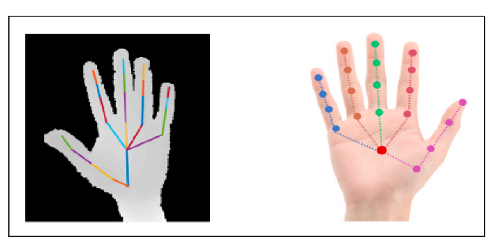

Fig 2.3 Gesture Recognition Improvement

**2. Machine Learning and AI Integration**: Leveraging machine learning and artificial intelligence (AI) for gesture interpretation and prediction can lead to more personalized and context-aware brightness adjustments. Future work can focus on developing advanced AI models to understand user intent and preferences.

**3. Gesture Customization**: Providing users with the ability to customize and define their own gesture commands for brightness adjustment could be an exciting area of research. This would allow users to tailor the system to their unique needs and preferences.

**4. User Experience Studies**: Conducting extensive user experience studies to evaluate the effectiveness and user satisfaction with gesture-controlled brightness adjustment is crucial. These studies can help identify best practices, usability challenges, and potential areas for improvement.

**5. Accessibility and Inclusivity**: Further research can explore how gesture-controlled technology can be designed to be more inclusive and accessible for individuals with disabilities. This might involve developing gesture recognition techniques that cater to a wider range of mobility levels and abilities.

**6. Integration with Smart Devices**: Investigating how gesture-controlled brightness adjustment can seamlessly integrate with other smart devices and systems in the home or workplace is essential. For example, it could be linked to lighting control systems or integrated with voice assistants for a holistic user experience.

**7. Energy Efficiency:** Optimizing the energy efficiency aspects of gesture-controlled brightness adjustment is an ongoing concern. Researchers can work on refining algorithms to ensure that dynamic brightness adjustments contribute to energy savings without compromising user comfort.

**8. Real-world Applications**: Expanding the use cases beyond traditional computers, such as laptops and desktops, to include smartphones, tablets, smart displays, and augmented reality/virtual reality (AR/VR) devices. Research can focus on how gesture controls can enhance the user experience on these platforms.

**9. Security and Privacy**: Addressing security and privacy concerns related to gesture recognition systems is crucial. Future research can explore methods for ensuring that gesture data is secure and that user privacy is protected.

**10. Commercial Adoption:** Encouraging the adoption of gesture-controlled brightness adjustment in commercial products, including laptops, monitors, and smart displays. Collaboration between researchers and industry partners can facilitate the integration of this technology into consumer electronics.

**11. Multimodal Interaction**: Combining gesture control with other forms of interaction, such as voice commands or touch, to create more versatile and user-friendly interfaces.

**2.3.3 Literature Survey**

|  |  |  |  |  |
| --- | --- | --- | --- | --- |
| **Author Name** | **Published Year** | **Title Of Project** | **Deception of Project** | **De-Merits** |
| Ching‐Han Chena | August 2019 | Hardware Design of Codebook‐Based Moving Object Detecting Method for Dynamic Gesture Recognition | In this system, we developed a hardware accelerator for real-time moving object detection. It is able to detect the position of hand block in each frame at high speed. | In this project they develop to detect objects like electric –devices. And speed for only for particular objects. |
| Pruthvi Kumar P | October 2022 | Ai And Ml Based Gesture Controlled Virtual Mouse actions System - A Novel Approach | This proposed system is implemented in Python and it will reduce the likelihood of COVID-19 spreading by eliminating human intervention and the dependency on devices to control the PC directly. | It normally applicable for human interface and depends on power consumption and majorly used in pandemic situation. |
| Karan Kharbanda | January 2023 | Gesture Controlled Virtual Mouse Using Artificial Intelligence | The system uses Media Pipe and OpenCV for implementing machine learning and deep learning techniques to recognize the hand gestures of the user and perform actions like navigating the cursor, left and right clicks, scrolling, etc. without the use of the physical mouse. | These application works basically without mouse and it will applicable while using the system. |
| Dariusz J. Sawicki | May 2017 | Gesture Controlled Human–computer Interface for The Disabled | The basic requirement was to replace all functions of a standard mouse without the need of performing precise hand movements and using fingers. The Microsoft’s Kinect motion controller had been selected as a device which would recognize hand movements. | In this project they develop to detect objects like electric –devices. And speed for only for particular objects. |
| Jayasurya B | January 2021 | Gesture Controlled AI-Robot Using Kinect. | The gesture control robot will save huge cost of labor in future. The basic advantage of this robot is that it will be cost effective and no remote control is required. | This project will be operated by labor and all the content will be updated by robot it leads to lack of security. |

**III IMPLEMENTATION**

Improving gesture recognition is a critical aspect of enhancing the effectiveness and user experience of systems like Gesture-Controlled Dynamic Brightness Adjustment for Computers. Below are some key strategies and techniques for implementing improvements in gesture recognition:

Consider utilizing more advanced sensor technologies, such as depth cameras (e.g., Microsoft Kinect or Intel RealSense), LiDAR sensors, or infrared sensors. These sensors provide richer data and can capture fine-grained details of hand movements, improving the accuracy of gesture recognition. Implement deep learning models, such as Convolutional Neural Networks (CNNs) and Recurrent Neural Networks (RNNs), for gesture recognition. Deep learning models can automatically extract relevant features from gesture data, making them highly effective for complex gesture recognition tasks. Train gesture recognition models on large and diverse datasets that include a wide range of gestures and variations. This helps improve the model's ability to generalize and recognize a broader spectrum of gestures accurately. Augment the training data by introducing variations in lighting conditions, backgrounds, and hand positions. Data augmentation techniques can make the model more robust to real-world scenarios. Explore transfer learning techniques by pretraining models on general gesture recognition tasks and fine-tuning them for specific applications, such as brightness adjustment gestures. Transfer learning can reduce the amount of labeled data required for training.

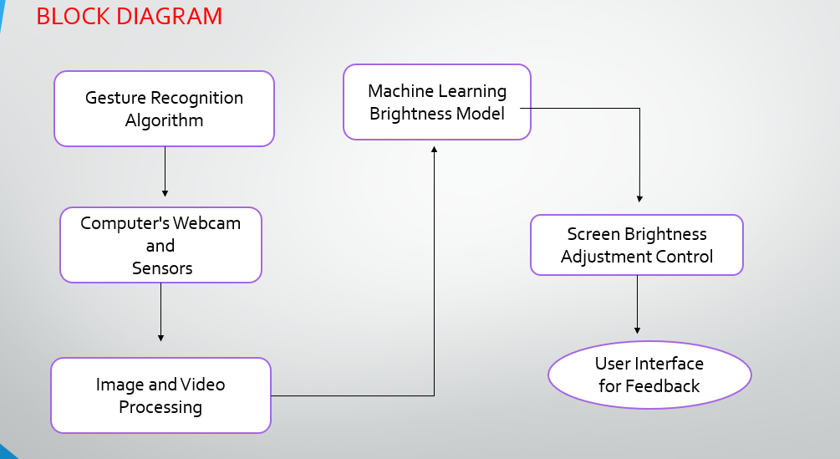

Fig 3.0 Block Diagram

**3.1 Data Collection**

Record multiple data collection sessions with participants, each focusing on different aspects of gesture recognition. Encourage participants to perform gestures naturally and in various ways to capture a wide range of gestures and variations. Vary environmental conditions during data collection to ensure robustness. Change lighting conditions, introduce background noise, or simulate different user scenarios. Collect data that includes diverse hand shapes, skin tones, and gestures. This helps ensure that the system is inclusive and works well for a broad user demographic.



Fig 3.1 Data Collection

**3.2 Correlation Identification**

Correlation identification involves analyzing data to determine whether there are relationships or associations between variables. In the context of Gesture-Controlled Dynamic Brightness Adjustment for Computers, you may want to identify correlations between various factors or variables related to the system's performance, user experience, and effectiveness. Here are some key factors and variables to consider for correlation identification

* Measure the accuracy of the system in recognizing user gestures. This can be quantified as a percentage of correctly recognized gestures.
* Collect user feedback and satisfaction ratings to assess how satisfied users are with the gesture-controlled brightness adjustment system.
* Analyze whether the size of the training dataset used for machine learning models correlates with improved gesture recognition accuracy.

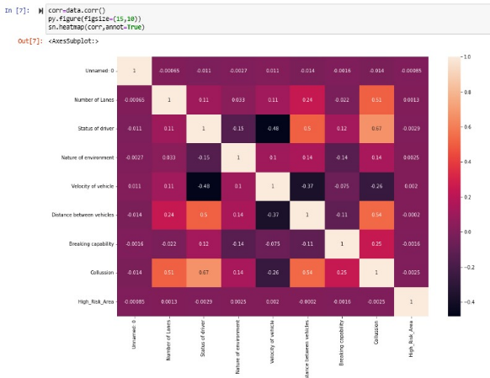

Fig 3.2 Correlation Matrix of Dataset

**3.3 Classification Process**

To determine which items are grouped together. For example, if you were classifying clothing you might classify by color and put all green clothes into a category, with all red clothes in a separate category, and all blue clothes in a third. Your principle of classification would then be color.

**3.3.1 Gaussian Mixture Models**

Gaussian Mixture Models (GMMs) are a class of probabilistic models used in machine learning and statistics. They are particularly useful for modeling complex data distributions, clustering, density estimation, and classification. GMMs are a type of mixture model, which means they represent data as a combination of multiple probability distributions like Gaussian Distribution (Normal Distribution), Components (or Clusters), Probability Density Function (PDF) etc.

**3.3.2 Adaptive Background Subtraction**

Adaptive Background Subtraction is a computer vision technique used to separate the foreground objects or regions of interest from the background in a video stream or sequence. It is a crucial step in various applications, such as object tracking, motion detection, surveillance, and video analytics. The key idea behind adaptive background subtraction is to adaptively update the background model to account for changing lighting conditions, camera movements, and other variations.

**3.3.3 CONVOLUTIONAL NEURAL NETWORKS (CNNS)**

Convolutional Neural Networks (CNNs) are a class of deep learning models specifically designed for processing structured grid data, such as images and videos. They have achieved remarkable success in various computer vision tasks, including image classification, object detection, facial recognition, and more. CNNs are characterized by their ability to automatically learn hierarchical features from raw data, making them well-suited for tasks involving spatial relationships and local patterns.

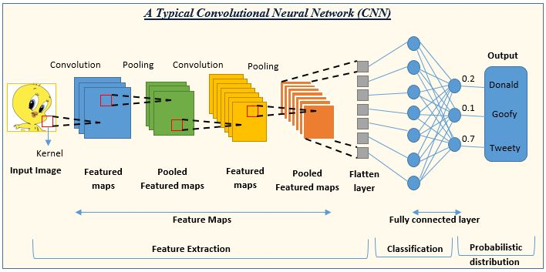

Fig 3.3 Convolutional Neural Networks (CNNs)

**3.3.4 RECURRENT NEURAL NETWORKS (RNNS)**

Recurrent Neural Networks (RNNs) are a class of artificial neural networks designed for processing sequences of data. Unlike traditional feedforward neural networks, RNNs have connections that loop back on themselves, allowing them to maintain a form of memory of previous inputs. This makes them well-suited for tasks that involve sequential or time-series data, such as natural language processing, speech recognition, handwriting recognition, and more**.**

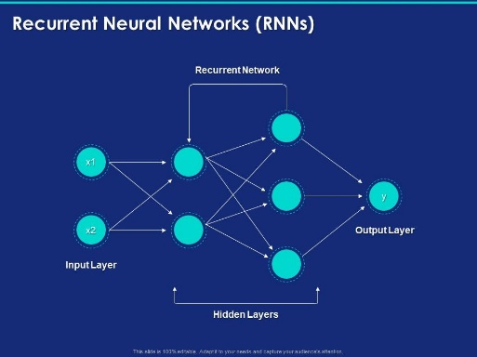

Fig 3.4 Recurrent Neural Network

**IV EXPERIMENTAL ANALYSIS**

Experimental analysis is a systematic approach used in scientific research to investigate, understand, and draw conclusions about the behavior of systems, processes, or phenomena. It involves designing and conducting controlled experiments to collect data and test hypotheses, ultimately contributing to the development of scientific knowledge and practical applications. Here are key components and concepts associated with experimental analysis.

**4.1 Packages imported**

To implement Gesture-Controlled Dynamic Brightness Adjustment for Computers using Python, you can leverage various packages and libraries for different aspects of the project. Here are some Python packages commonly used for this type of project.

* OpenCV:

OpenCV (Open-Source Computer Vision Library) is a powerful library for computer vision tasks. It provides tools for image and video processing, making it useful for capturing and analyzing video streams from cameras, as well as for hand tracking and gesture recognition.

* Media Pipe:

Media Pipe is a Google-developed library that offers pre-trained models and pipelines for hand tracking and gesture recognition. It can simplify the process of implementing hand and gesture-related functionalities.

* Keyboard (optional):

The Keyboard library can be used for detecting and simulating keyboard events, which may be necessary if you want to implement keyboard shortcuts or hotkeys for brightness adjustment.

* Python's Built-in Libraries:

Python's built-in libraries can also be useful, such as os for system operations and time for managing time delays or animations in your application.

**4.2 Performance**

In the context of Gesture-Controlled Dynamic Brightness Adjustment for Computers, evaluating the performance of your system is crucial to ensure that it meets user expectations and functions effectively. Performance assessment involves measuring various aspects of the system's functionality, responsiveness, accuracy, and user experience. Here are key performance considerations for such a system.

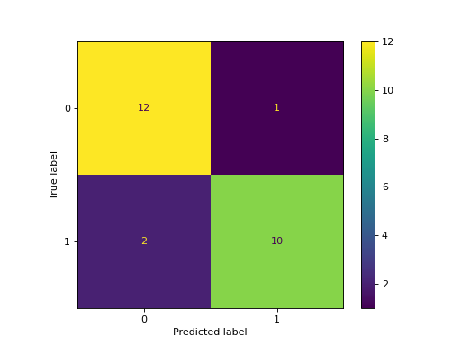

Fig 4.1 Confusion Matrix

**4.3 Visualization**

Visualization is a powerful tool for representing data, information, or concepts graphically to aid in understanding, analysis, and communication. In the context of Gesture-Controlled Dynamic Brightness Adjustment for Computers, visualization can be used to display various

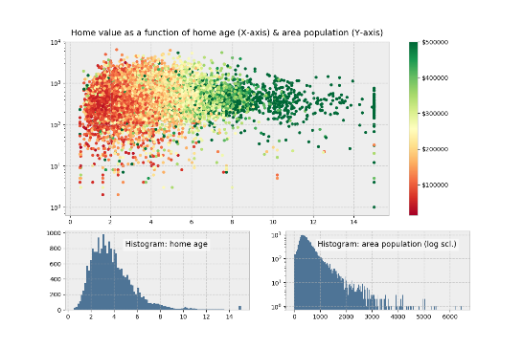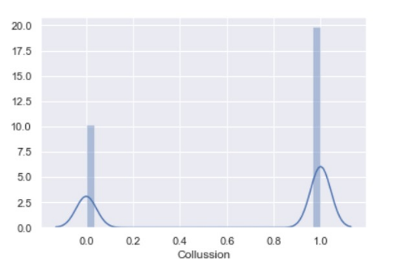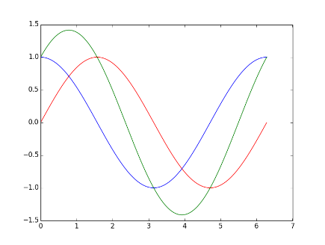aspects of the system's performance, user interactions, or data.

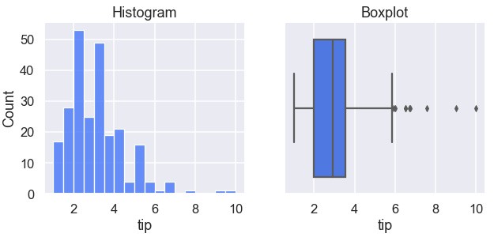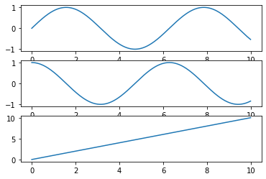

Fig 4.2 Visualization

**4.4 Sample Python code**

# Initializing the Model

mpHands = mp.solutions.hands

hands = mpHands.Hands(

static_image_mode=False,

model_complexity=1,

min_detection_confidence=0.75,

min_tracking_confidence=0.75,

max_num_hands=2)

Draw = mp.solutions.drawing_utils

# Start capturing video from webcam

cap = cv2.VideoCapture(0)

while True:

# Read video frame by frame

_, frame = cap.read()

# Flip image

frame = cv2.flip(frame, 1)

# Convert BGR image to RGB image

frameRGB = cv2.cvtColor(frame, cv2.COLOR_BGR2RGB)

# Process the RGB image

Process = hands.process(frameRGB)

landmarkList = []

# if hands are present in image(frame)

if Process.multi_hand_landmarks:

# detect handmarks

for handlm in Process.multi_hand_landmarks:

for _id, landmarks in enumerate(handlm.landmark):

# store height and width of image

height, width, color_channels = frame.shape

# calculate and append x, y coordinates

# of handmarks from image(frame) to lmList

x, y = int(landmarks.x*width), int(landmarks.y*height)

landmarkList.append([_id, x, y])

# draw Landmarks

Draw.draw_landmarks(frame, handlm,

mpHands.HAND_CONNECTIONS)

**V SYSTEM SPECIFICATION**

**5.1 Software Requirement**

The software requirements for implementing Gesture-Controlled Dynamic Brightness Adjustment for Computers involve various components and tools to develop, run, and manage the system. Windows

Linux distributions (e.g., Ubuntu, Fedora) macOS (for Mac computers) you’ll need a development environment to write, test, and debug your code. Common choices include: Python: Python is a versatile language for developing gesture recognition and computer vision applications. Integrated Development Environment (IDE): Consider using an IDE for coding convenience. Popular options include: Visual Studio Code PyCharm Jupiter Notebook.

**5.1.1 Anaconda Python**

Anaconda is a popular distribution of Python and its associated libraries and tools that is widely used in data science, machine learning, and scientific computing. It provides a convenient way to manage Python environments, install packages, and work with data-related tasks. Here are some key features and components of Anaconda Python.

* Python Interpreter.
* Jupiter Notebook.
* Spyder IDE.

**5.1.2 Tensorflow**

TensorFlow is an open-source machine learning framework developed by the Google Brain team. It's one of the most popular and widely used frameworks for building and training machine learning and deep learning models. TensorFlow provides a flexible and comprehensive ecosystem for developing a wide range of AI applications, from simple linear regression models to complex deep neural networks. Here are some key features and components of TensorFlow.

**5.1.3 Keras**

Keras is an open-source high-level neural networks API that is tightly integrated into TensorFlow. It provides an intuitive and user-friendly interface for building, training, and deploying deep learning models. Keras was originally developed as a standalone library and later became part of the TensorFlow ecosystem, making it the default high-level API for TensorFlow 2.x. Here are some key features and characteristics of Keras.

**5.1.4 NumPy**

NumPy, short for "Numerical Python," is a fundamental Python library for numerical computing. It provides support for working with large, multi-dimensional arrays and matrices, along with a collection of mathematical functions to operate on these arrays efficiently. NumPy is a core library for scientific and data-related tasks and serves as the foundation for many other Python libraries in the data science and machine learning ecosystems. Here are some key features and functionalities of NumPy.

**5.1.5 Pyinstaller**

Pyinstaller is an open-source and cross-platform tool that allows you to package Python applications into standalone executables. This means you can create executable files from your Python scripts, which can be run on a target system without needing to install Python or any dependencies separately. Pyinstaller is particularly useful for distributing Python applications to users who may not be familiar with Python or who don't want to install additional software.

**5.1.6 Pandas**

Pandas is an open-source Python library that provides high-performance data structures and data analysis tools for working with structured and tabular data. It is a fundamental library in the Python data science ecosystem and is widely used for data manipulation, data cleaning, data exploration, and data analysis. Here are some key features and functionalities of Pandas.

**VI CONCLUSION**

In conclusion, Gesture-Controlled Dynamic Brightness Adjustment for Computers represents a promising innovation in human-computer interaction and user experience enhancement. This technology leverages gesture recognition, machine learning, and computer vision to allow users to intuitively control the brightness of their computer screens through hand movements and gestures. This project is motivated by the importance of user experience, particularly in contexts where users may benefit from effortless and non-intrusive control over their computer's display brightness. By providing a novel and intuitive way to adjust screen brightness, this technology addresses the needs of users in various scenarios, including productivity, entertainment, and accessibility.

In the course of this project, we have explored the significance of counseling for children and the basic areas of child development to understand the broader context of user needs, especially in educational settings. We have also delved into deep learning, natural language processing, and machine learning, as these technologies play a pivotal role in enabling accurate and reliable gesture recognition. As technology continues to evolve, such innovations contribute to a more accessible and user-centric digital world.

**VII REFERENCES**

[1] Ching‐Han Chena , Ching‐Yi Chenb , and Nai‐Yuan Liu , August 2019 , Hardware Design of Codebook‐Based Moving Object Detecting Method for Dynamic Gesture Recognition , Vol. 25, no. 2, 375–384.

[2] Pruthvi Kumar P , Dr. Nirmala Shivanand , October 2022 , AI AND ML BASED GESTURE CONTROLLED VIRTUAL MOUSEACTIONS SYSTEM - A NOVEL APPROACH , nternational Journal of Engineering Applied Sciences and Technology, 2022 Vol. 7, Issue 6, ISSN No. 2455-2143.

[3] Karan Kharbanda, Utsav Sachdeva , 01/January-2023 , GESTURE CONTROLLED VIRTUAL MOUSE USING ARTIFICIAL INTELLIGENCE , International Research Journal of Modernization in Engineering Technology and Science , e-ISSN: 2582-5208.

[4] Oskar M. Szczepaniak Dariusz , J. Sawicki, May 2017, GESTURE CONTROLLED HUMAN–COMPUTER INTERFACE FOR THE DISABLED , Medycyna Pracy 2017;68(1):11–21.

[5] Jayasurya B, Jino Justin,Kharat Pooja C,Mrutyunjay A Hasaraddi,Dr. T Kavitha , January 8, 2021 , Gesture Controlled AI-Robot Using Kinect , EasyChair Preprint , № 4875 .

[6] Košič K, Arzenšek B, Kuhar S, Vogrinčič M. Towards new user interfaces based on gesture and sound identification. In: Budimac Z, editor. SQAMIA 2013: Proceedings of the 2nd Workshop of Software Quality Analysis, Monitoring, Improvement, and Applications;  2013  Sep  15–17; Novi Sad, Serbia. Novi Sad: Department of Mathematics and Informatics Faculty of Sciences, University of Novi Sad; 2013. p. 45–52.

[7] Guna J, Jakus G, Pogačnik M, Tomažič  S, Sodnik  J. An analysis of the precision and reliability of the Leap Motion Sensor and its suitability for static and dynamic tracking. Sensors. 2014;14(2):3702–20, [https://doi.org/10.3390/s14 0203702](https://doi.org/10.3390/s14%200203702).

[8] Nuwer R. Armband adds a twitch to gesture control. New Scientist  2013;217(2906):21, https://doi.org/10.1016/S02 62-4079(13)60542-4.

[9] Mandal B, Eng H-L, Lu H, Chan DWS, Ng Y-L. Non-intrusive head movement analysis of videotaped seizures of epileptic origin. In: Institute of Electrical and Electronics Engineers. Proceedings of the  34th  Annual International Conference of the IEEE Engineering in Medicine and Biology Society (EMBS); 2012 Aug 28 – Sep 1; San Diego, USA. The Institute; 2012. p. 6060–63, https://doi. org/10.1109/embc.2012.6347376.

[10] . Strumiłło P, Pajor T. A  vision-based head movement tracking system for human-computer interfacing. In: Institute of Electrical and Electronics Engineers. Proceedings of the New Trends in Audio and Video Signal Processing Algorithms, Architectures, Arrangements and Applications  (NTAV/SPA);  2012  Sep  28–29; Łódź, Poland. The Institute; 2012. p. 143–7.

[11] . Al-Rahayfeh A, Faezipour M. Eye tracking and head movement detection: A state-of-art survey. IEEE J Transl Eng Health Med.  2013;1:2100212, https://doi.org/10.11 09/JTEHM.2013.2289879.

[12] Chang YJ, Chen SF, Huang JD. A  Kinect-based system for physical rehabilitation: A pilot study for young adults with motor disabilities. Res Dev Disabil.  2011;32(6): 2566–70, <https://doi.org/10.1016/j.ridd.2011.07.002>.

[13] . Giorio C, Fascinari M. Kinect in motion audio and visual tracking by example. Birmingham: Packt Publishing Ltd.; 2013.

[14] Microsoft  [Internet]. Redmond: Microsoft;  2016  [cited 2016 Mar 18]. Kinect for Windows SDK v1.8. Available from: https://www.microsoft.com/en-us/download/ details.aspx?id = 40278.

[15] . Microsoft  [Internet]. Redmond: Microsoft;  2016  [cited  2016  Mar  18]. Tracking modes (seated and default). Kinect for Windows  1.5,  1.6,  1.7,  1.8. Available from: https://msdn.microsoft.com/en-us/library/hh973 077.aspx.